Payeer for CMS Amiro 7.0.0.14

Copy the contents of the module in your site root folder (if asked to overwrite files, accept overwriting)
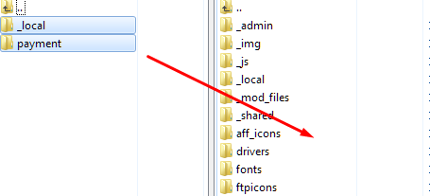

After that, go to admin panel CMS Amiro and in the main menu go to Service -> Payment methods
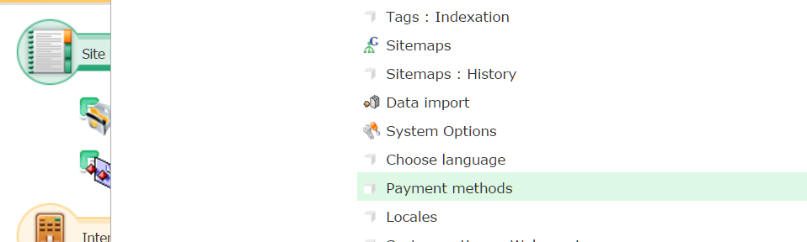

Open driver settings Payeer.
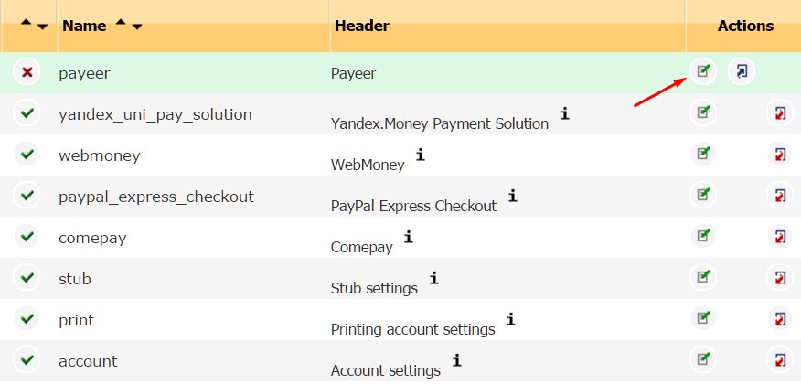

In the resulting edit box enter the required parameters.
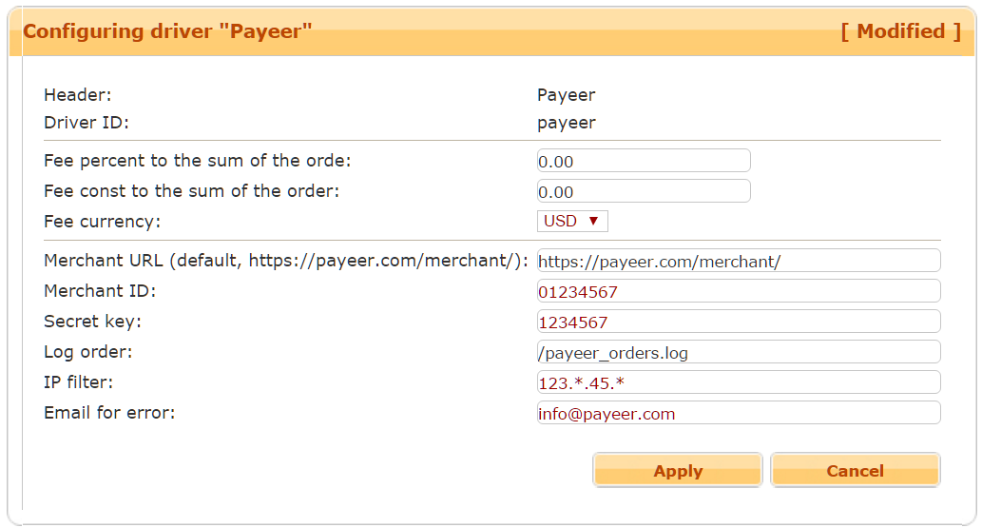

Merchant URL — the default path to the payment https://payeer.com/merchant/
Merchant ID – id of your store in the system Payeer.com (can be found in the personal cabinet).
Secret key – the secret key of your store.
If you specify the path to the file logging, you will be recording information about payments via Payeer.
You can specify the list of all trusted ip addresses of servers, separated by commas. You can also specify a mask instead of the ip address. If the field is empty, checking for trusted ip addresses is not implemented.
For example:
192.168.71.87, 192.165.83.17, 192.178.34.15
Or 192.*.71.87, 192.165.83.*, 192.*.34.15
Or *.*.*.* - all available ip addresses.

Enter your email address to receive notices in the event of an error of payment. The letter will state the reason and basic information about the payment.
Click apply. Then install the module:
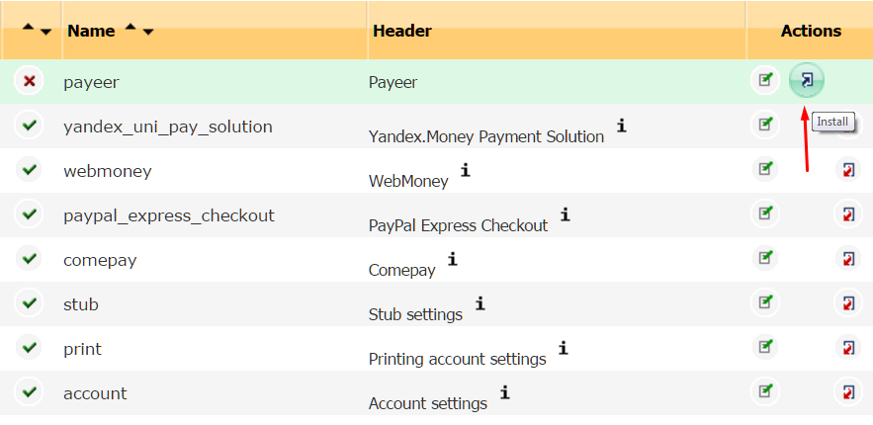

Open the settings for “E-Commerce: Orders”.
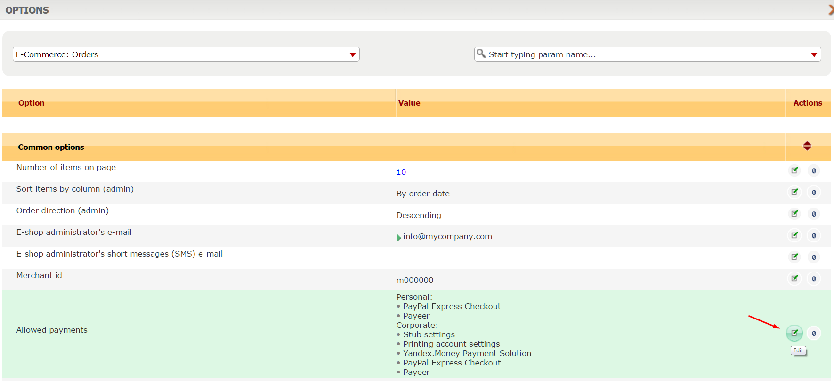

In the allowed payments methods select Payeer.
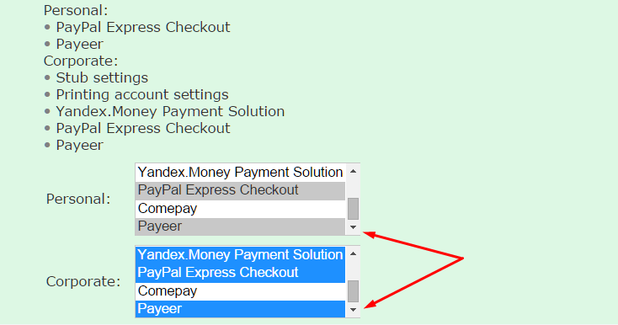

Click “Apply changes”.
In order the payment method appears in the list of available methods, you must add the language setting the name of the payment system Payeer.
Please visit the main page of the admin panel in “Site Management -> Site Templates”.
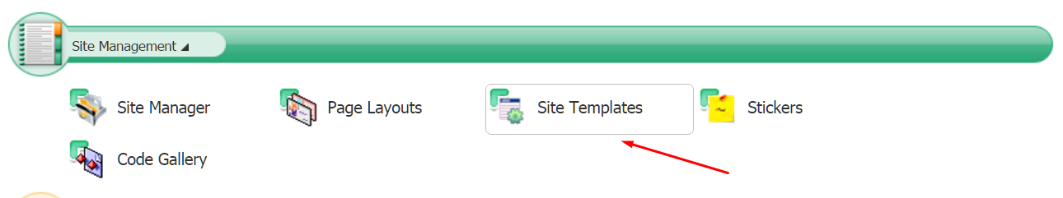

Next, go to the tab “Localizations”.
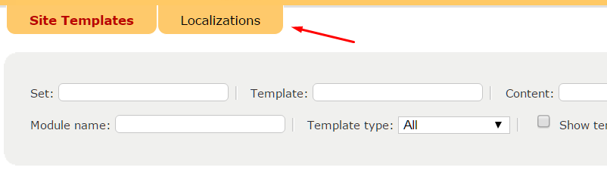

Putting in in the filter template eshop_purchase.lng, locate the template and open it for editing.
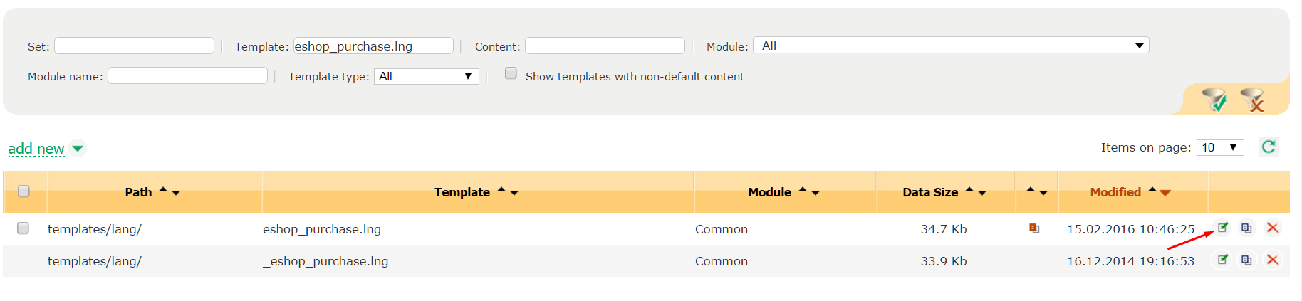

At the end add the lines of the description of the payment system Payeer, then press OK.
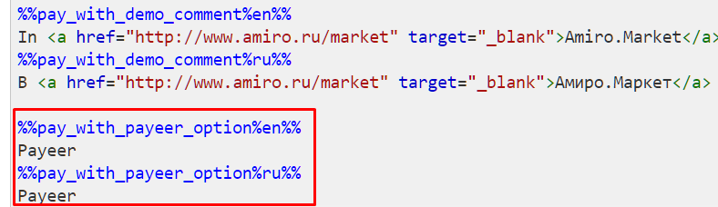

The module in the admin panel is configured.

Then, enter the URL address in the “Dashboard Payeer → Merchant → Settings”
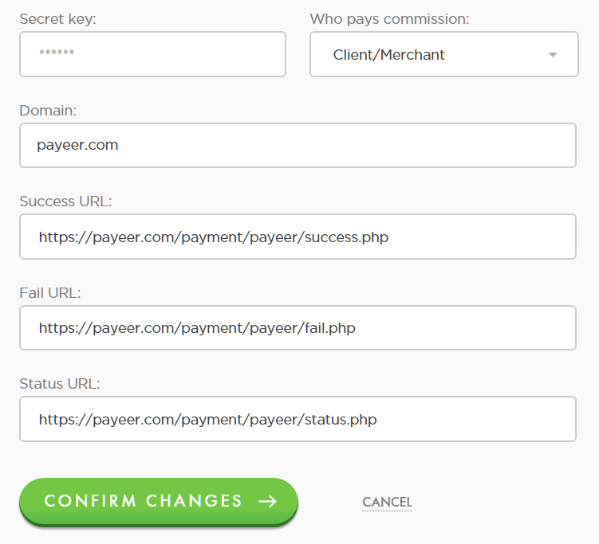

Success URL
http:// *****/payment/payeer/success.php
Fail URL
http:// *****/payment/payeer/fail.php
Status URL
http:// *****/payment/payeer/status.php
Where ***** is your domain.
Confirm changes.
Payeer module for CMS Amiro 7.0.0.14 configured.

